Archiving Modes

Periodic 2

Absolute 3

Relative 4

Threshold 5

Difference 6
Periodic

Attribute is archived at fixed frequency
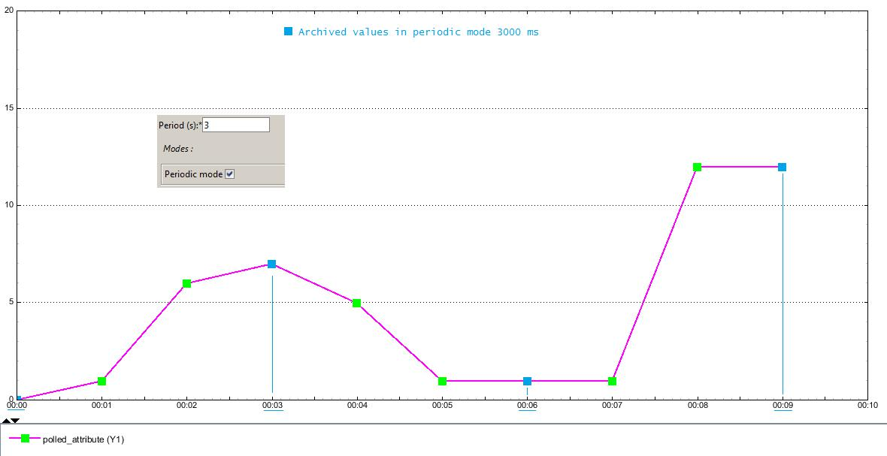

2/6

Absolute

Attribute is archived if:

current < previous - lowerlimit

current > previous + upper limit
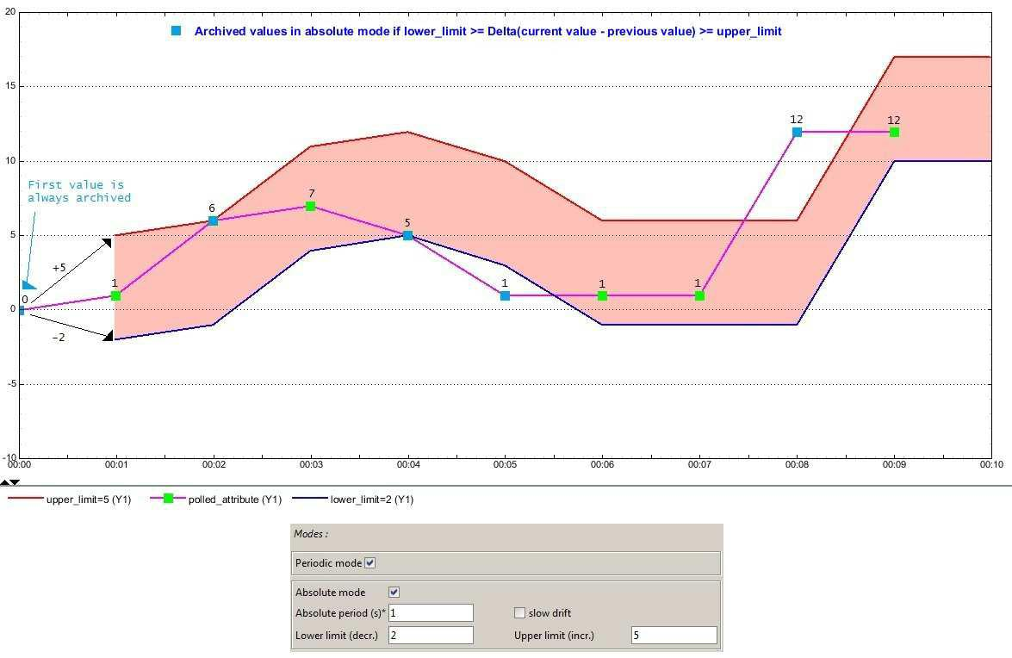

Slow drift option:

- slow drift = false => The comparison is done with the previous read value.

- slow drift = true => The comparison is done with the previous archived value.
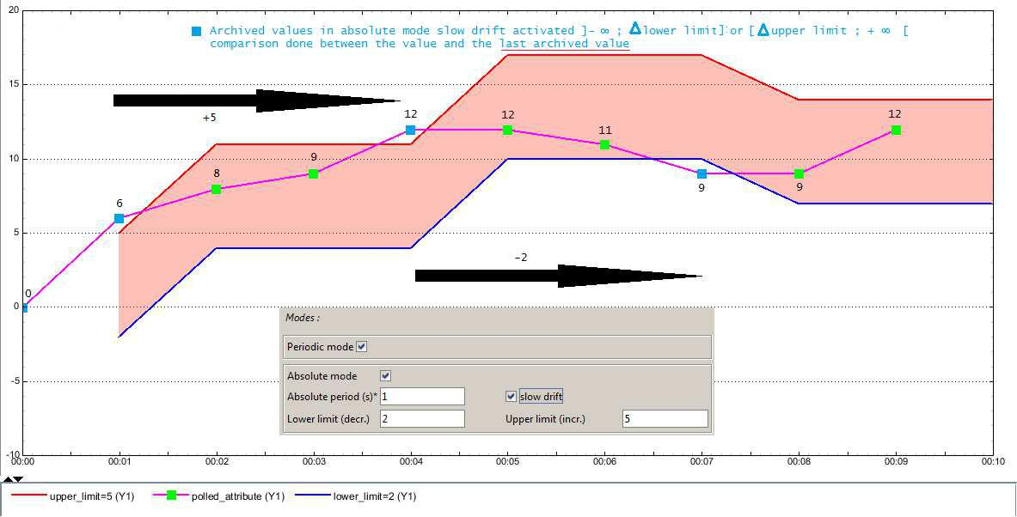

3/6
Relative

Attribute is archived if:

current > previous + previous * upper percent limit current < previous - previous * lower percent limit
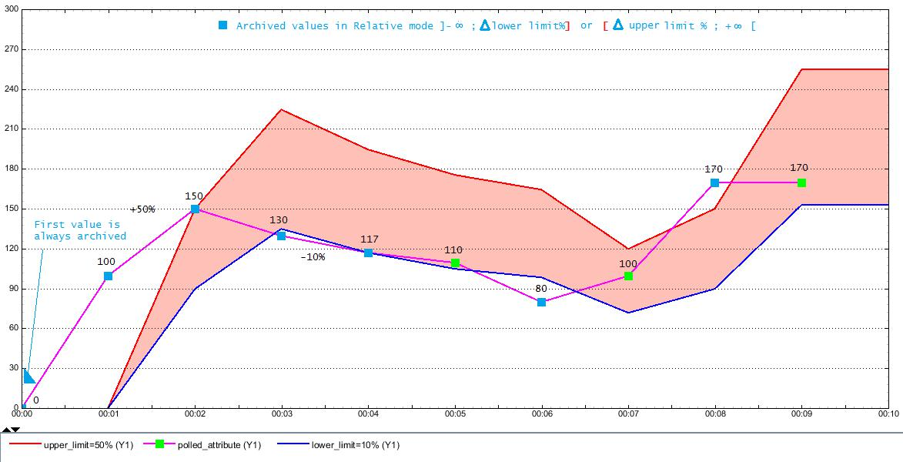

Slow drift option:

- slow drift = false => The comparison is done with the previous read value.

- slow drift = true => The comparison is done with the previous archived value.
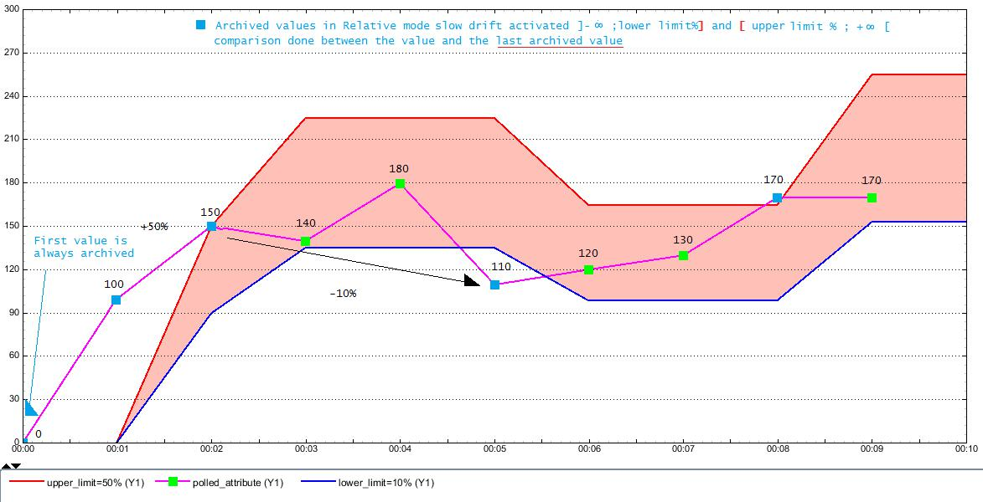

4/6
Threshold

Attribute is archived if:

current > upper limit

current < lower limit
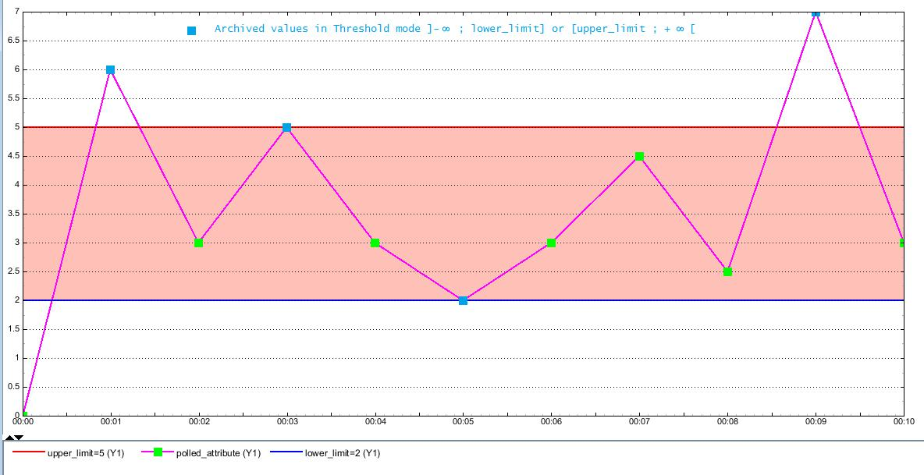

5/6
Difference

Attribute is archived if:

current!=previous
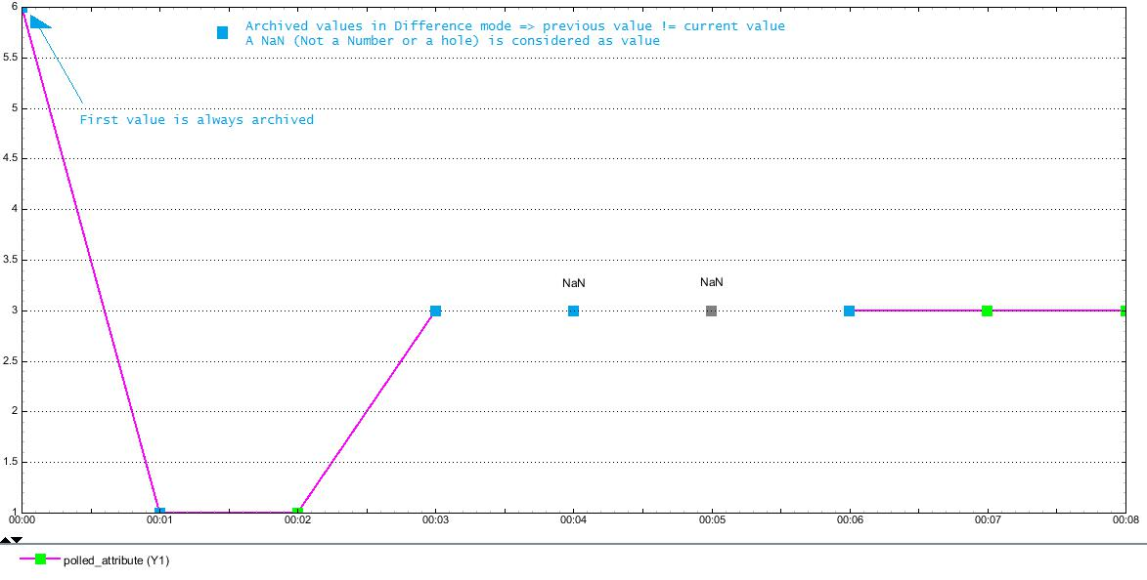

6/6

